Classification – Decision Tree

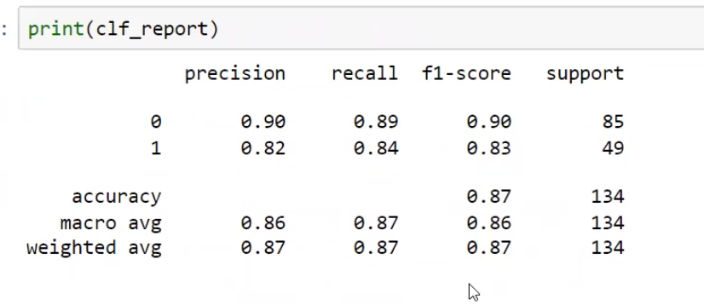
Precision
Q: When the model predicts a customer will NOT purchase, how often is it correct?
A: The model is correct 90% of the time when it predicts a customer will not make a purchase.
Q: When the model predicts a customer WILL purchase, how often is it correct?
A: The model is correct 82% of the time when it predicts a customer will make a purchase.

Recall
Q: Out of all customers who actually did NOT purchase, how many did the model successfully identify?
A: The model correctly identified 89% of actual non-purchasers.
Q: Out of all customers who actually purchased, how many did the model successfully identify?
A: The model correctly identified 84% of actual purchasers.

F1-Score
Q: How well does the model perform overall for non-purchasers by balancing correctness and coverage?
A: The model achieved an overall performance score of 90% for non-purchasers.
Q: How well does the model perform overall for purchasers by balancing correctness and coverage?
A: The model achieved an overall performance score of 83% for purchasers.

Support
Q: How many non-purchasing customers were evaluated?
A: The evaluation included 85 non-purchasing customers.
Q: How many purchasing customers were evaluated?
A: The evaluation included 49 purchasing customers.

Accuracy
Q: Overall, how often does the model make the correct prediction?
A: The model is correct 87% of the time across all customer predictions.

Macro Average
Q: What is the model's average performance when purchasers and non-purchasers are given equal importance?
A: The model achieved:
- 86% Precision
- 87% Recall
- 86% F1-Score
This indicates balanced performance across both groups regardless of their size.

Weighted Average
Q: What is the model's overall performance after considering the actual number of purchasers and non-purchasers in the dataset?
A: The model achieved:
- 87% Precision
- 87% Recall
- 87% F1-Score
This represents the model's practical performance on the dataset.

